* Node.js

## What is node js:

**Node.js** (Node js) is an **open-source** **and** **cross-platform**JavaScriptruntime environment. It runs on **Chrome’s V8 JavaScript engine**. It allows developers to run JavaScript code on the server. Node.js enables developers to get into the **server-side world.**

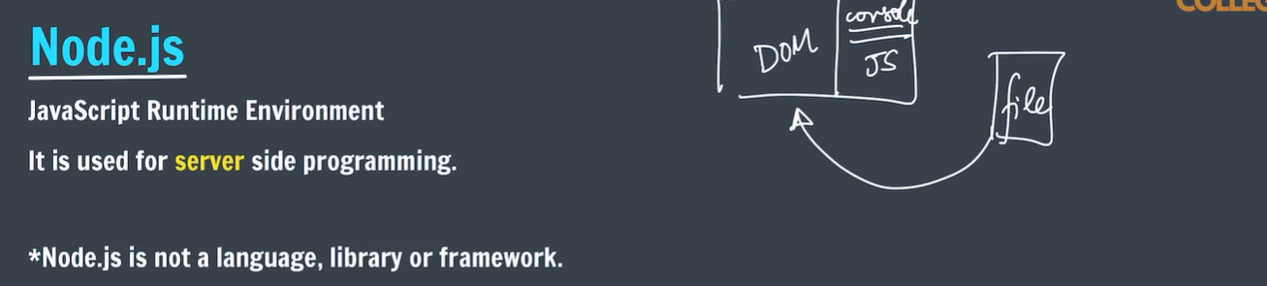

* “touch” is used to create file in cmd.

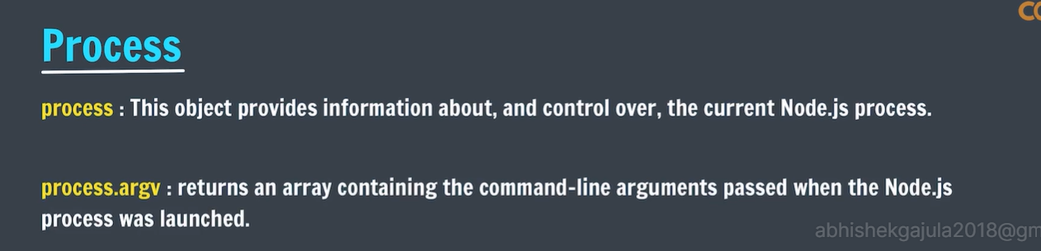

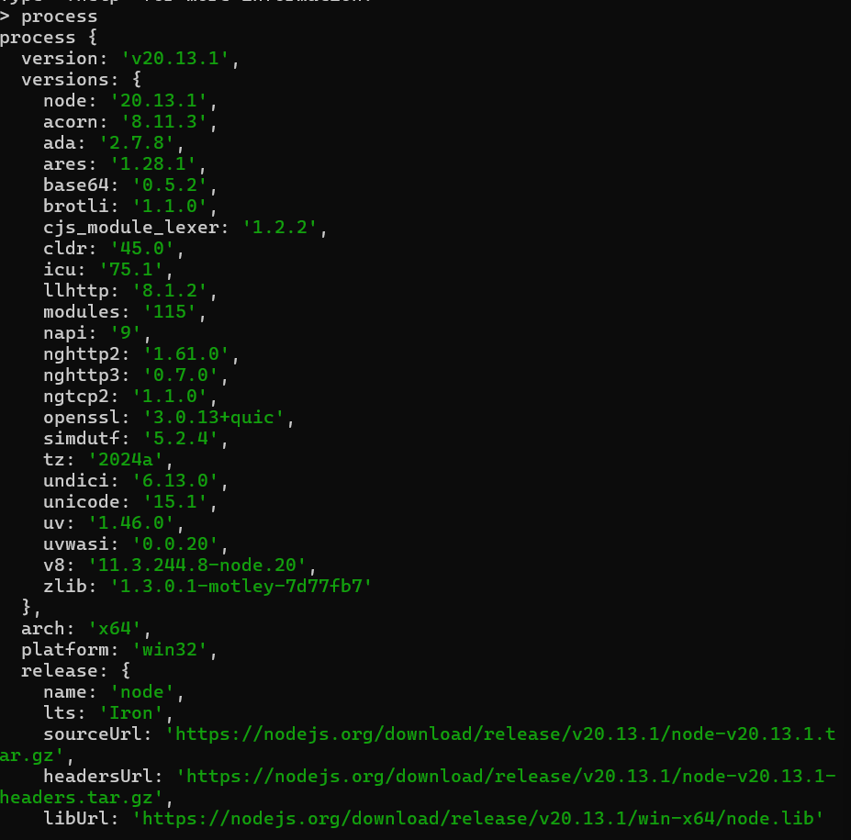

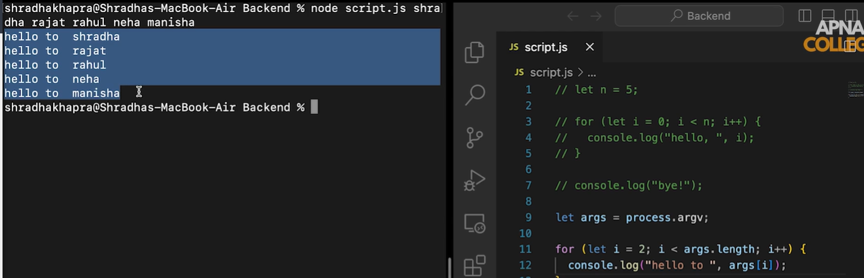

* First two arguments will be the node bin path and current working directory path.

# Who to share data between js files:

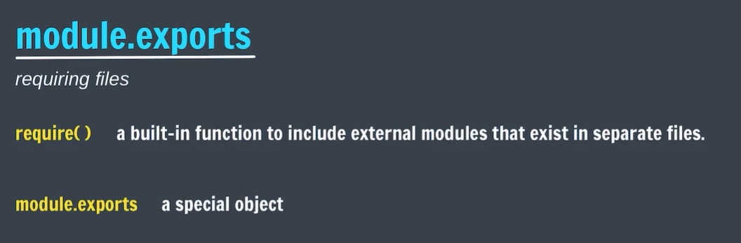

* You have function and some constants which are more often can used in other programs then this features will come into picture.

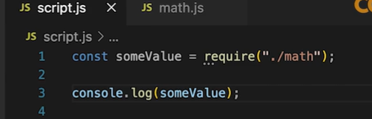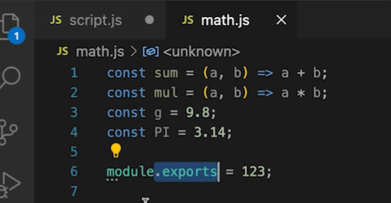

* If no data is there to export then require object will return empty object.

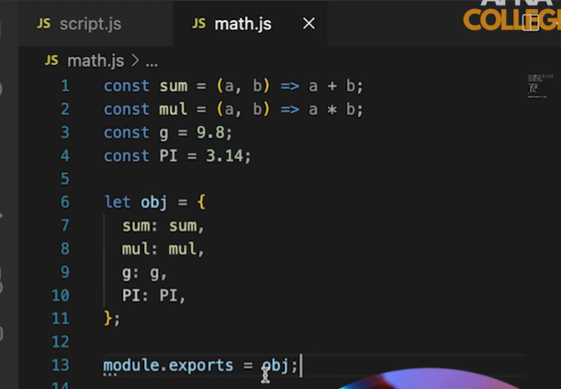

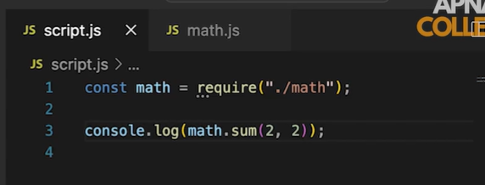

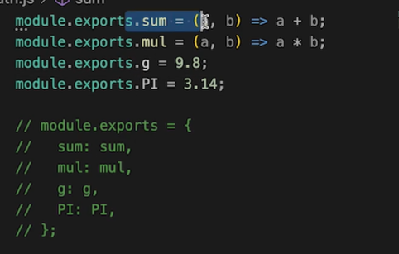

# Sharing the data between the different directories:

* Sharing among directories is same as sharing among files but the sharing directory should have an entry point which is index.js .
* In index.js we should collect all the data belongs to that folder and export form the file itself

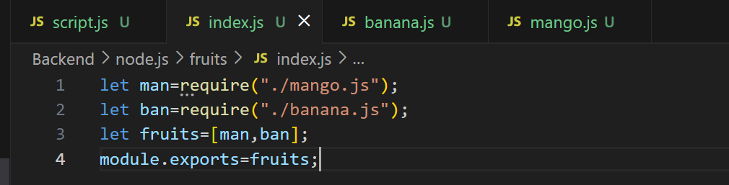

* And file that is collecting the data from the other folder should use require function with that folder function.

# Npm(node package manager):

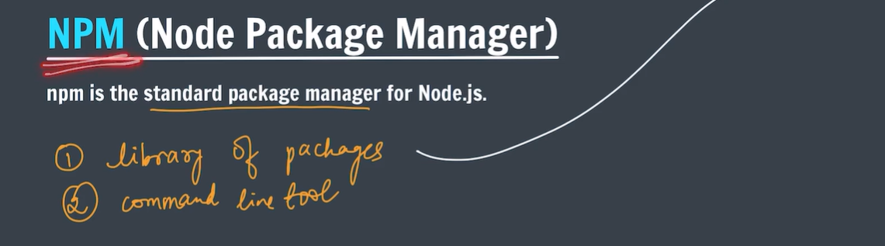

* Npm is a library of packages which manages the packages like express and react .
* It also provide command line tool which is use to download the packages to the developers.

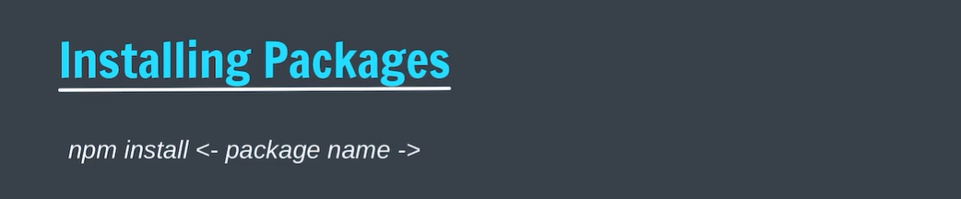

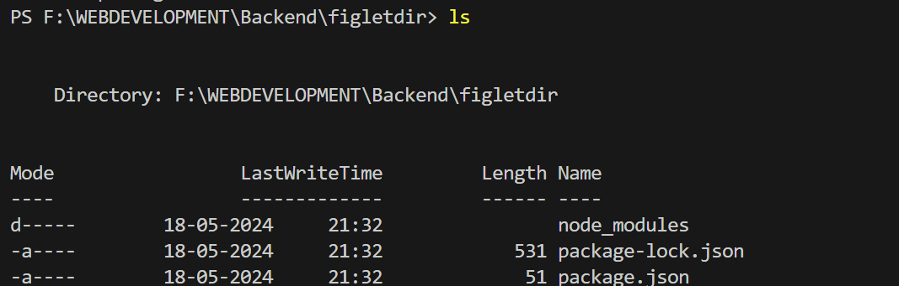

* If we download figlet the it contains above three above files by default.

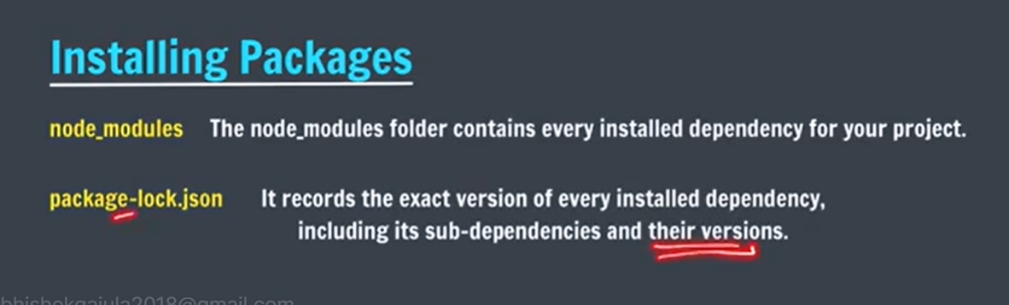

* Note : while using those packages we must and should be in the same directory where those packages are installed.

Install:

npm install figlet

Simple usage:

var figlet = require("figlet");

figlet("Hello World!!", function (err, data) {

if (err) {

console.log("Something went wrong...");

console.dir(err);

return;

}

console.log(data);

});

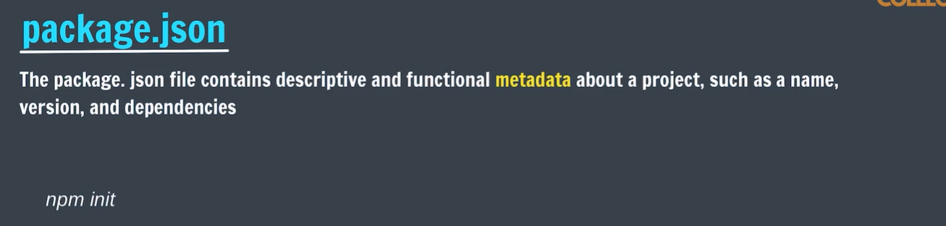

* Suppose if you want to send a project which is made by using some packages.you no need to send node modules you have to send only package.json in that you have all dependencies and functionality ,versions etc related to package used.
* For suppose if lost node module file we no need to worry we can re download with package.json file.
* Eg: delete the nodemodules and type “npm install” then we can easily re download the node modules.

# How to create package.json in our own project.

* Create a new directory .
* Go to that directory
* And type the command “npm init”

PS F:\WEBDEVELOPMENT\Backend\temp> npm init

This utility will walk you through creating a package.json file.

It only covers the most common items, and tries to guess sensible defaults.

See `npm help init` for definitive documentation on these fields

and exactly what they do.

Use `npm install <pkg>` afterwards to install a package and

save it as a dependency in the package.json file.

Press ^C at any time to quit.

package name: (temp)

version: (1.0.0)

description: how to use node in our new project

entry point: (index.js)

test command:

git repository:

keywords:

author: abhishek

license: (ISC)

About to write to F:\WEBDEVELOPMENT\Backend\temp\package.json:

{

"name": "temp",

"version": "1.0.0",

"description": "how to use node in our new project",

"main": "index.js",

"scripts": {

"test": "echo \"Error: no test specified\" && exit 1"

},

"author": "abhishek",

"license": "ISC"

}

Is this OK? (yes)

PS F:\WEBDEVELOPMENT\Backend\temp>

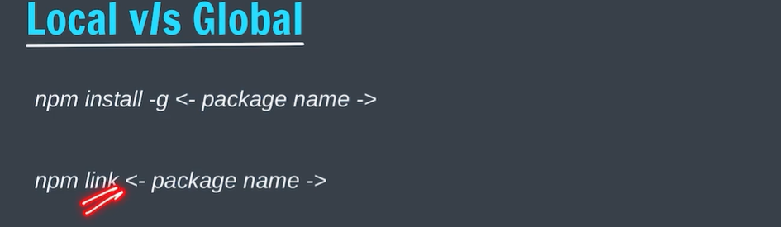

* First is used to install the packages globally.
* Second command is used link the package and current working directory.
* 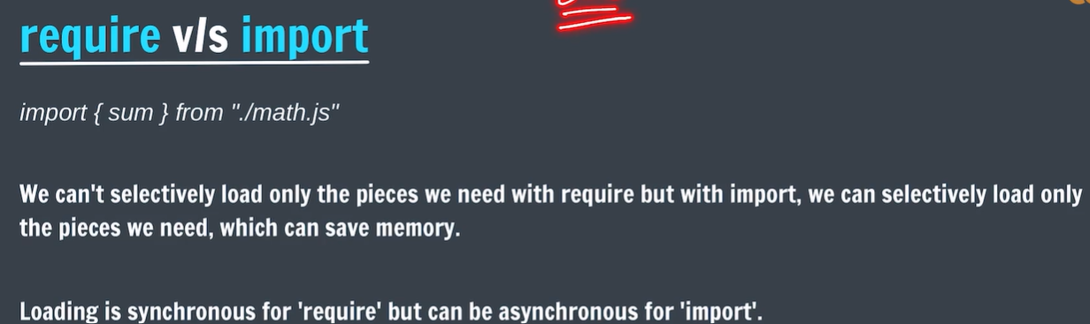After linking the package to our current working directory we can use that package.
* Note: you have to use either require or import but both is not recommended.
* Eg. Write the keyword ‘export’ before the statements which you want use in other folders.

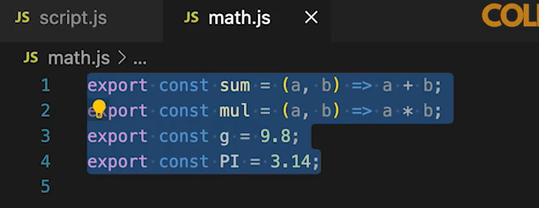

* Write the import in the file in which you want use other module features.

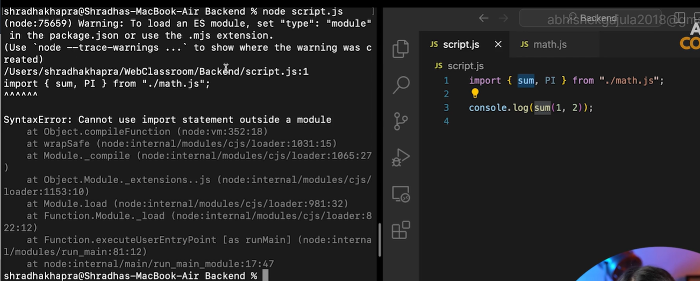

* It will show an error that in parent directory there should be a package.json file and in that a key value pair should contain “type”:”module”:

# Express js:

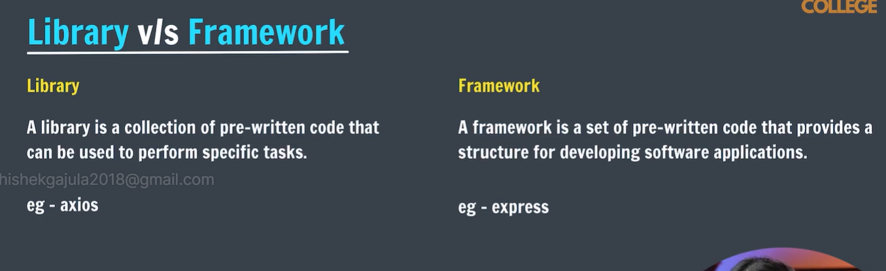

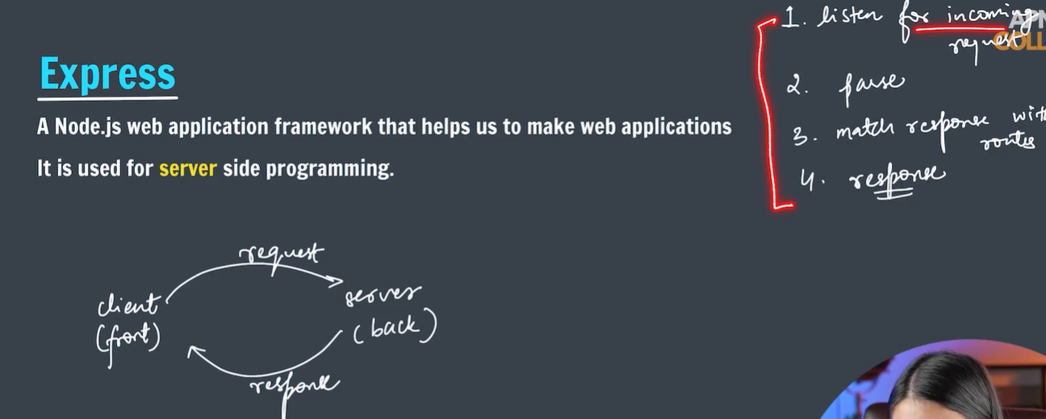

* It will listen for incoming request.
* Parse the incoming request.
* Match the response with routes.

Routes means the key words which is written after the domain and slash which is used to navigate to particular page of the website.

* Response.

# Installation of express:

* First create a dir and navigate to that dir and type “npm install”.
* Becoz it creates a package.json which provides some functionalities such as using of import statement and information of package dependencies. And it also add basic information about your project.

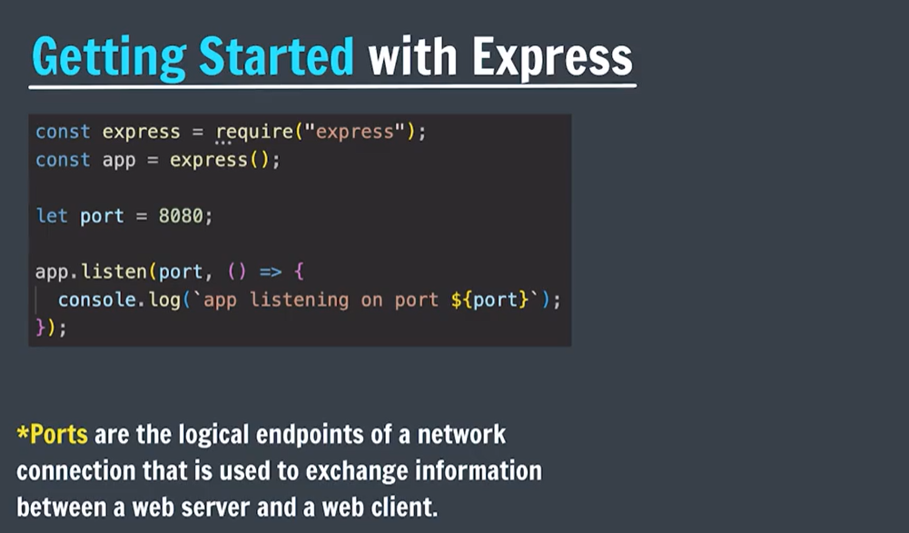

* Getting started with the server:

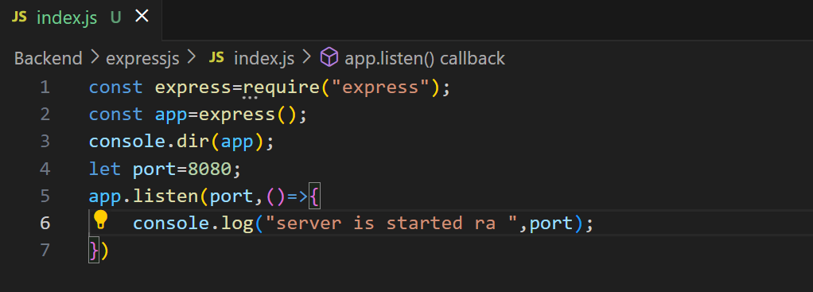

* Write the above program and name it as index.js give a port number (some port number are predefined for specific purpose ).
* Listen is the method of express object which always listen to the requests.

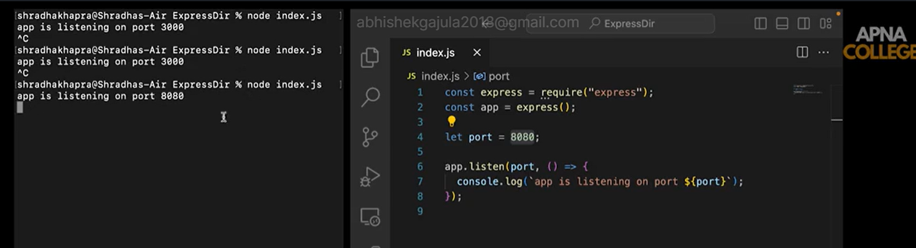

* Once if start the program by typing node index.js it will always listen the request until we stop it.
* To stop the server type”ctrl+c”
* We you want check the server working or not type”localhost:<portnumber>”

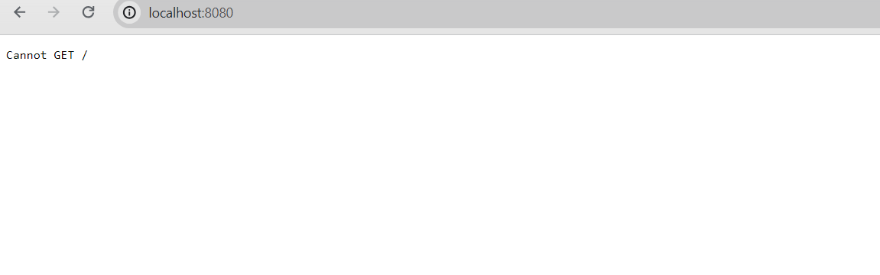

* We stop execution of index.js by “ctrl+c” it will stop listening and this case will happen even if you type wring port number.

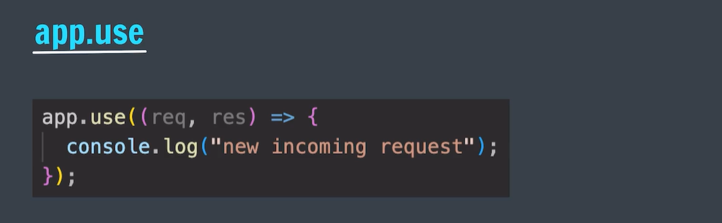

* It is used send the response to any type of request.
* You can check that In hopscotch but it doesn’t work with local api so you follow the given link to do that [**https://github.com/hoppscotch/hoppscotch/discussions/2051**](https://github.com/hoppscotch/hoppscotch/discussions/2051)
* **The above function has two default parameters req and res.**
* After downloading the extension refresh the page and restart the server.

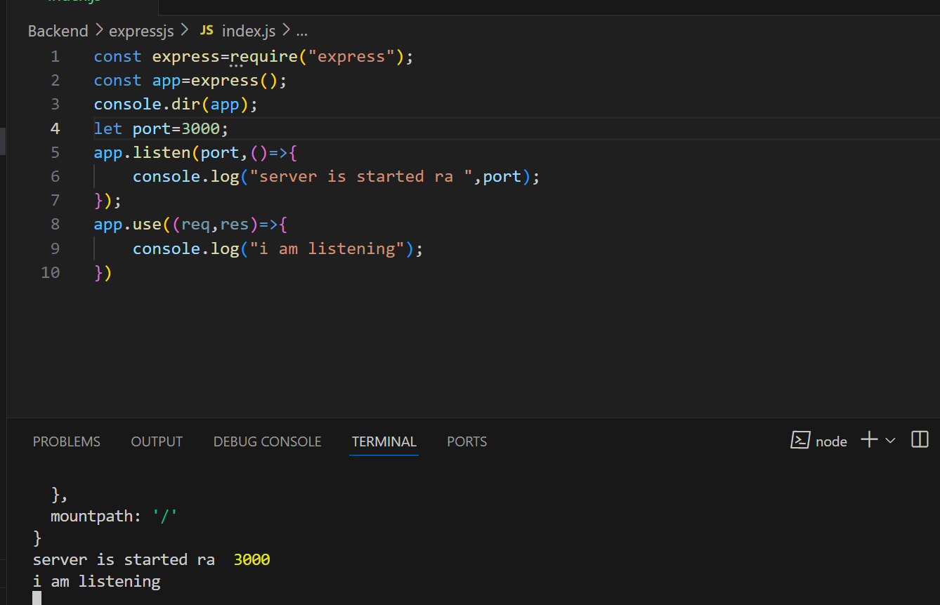

* I am listening will be printed when you send the request to the browser on <http://localhost:3000>

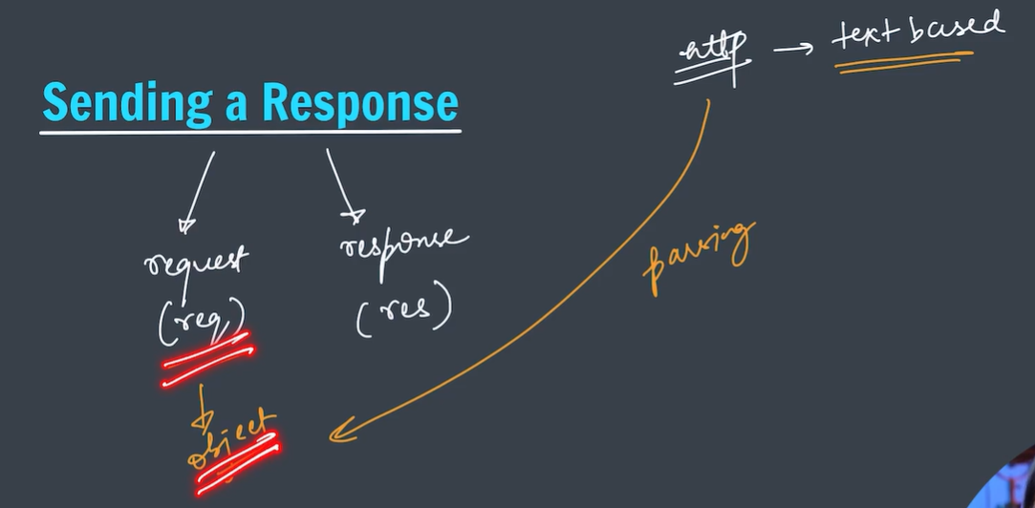

* Basically http request are text based why because they should not depend on server architecture.
* Express will convert that request to js object which is one of the main function of js called parsing.

### res.send([body])

Sends the HTTP response.

The body parameter can be a Buffer object, a String, an object, Boolean, or an Array. For example:

res.send(Buffer.from('whoop'))

res.send({ some: 'json' })

res.send('<p>some html</p>')

res.status(404).send('Sorry, we cannot find that!')

res.status(500).send({ error: 'something blew up' })

This method performs many useful tasks for simple non-streaming responses: For example, it automatically assigns the Content-Length HTTP response header field (unless previously defined) and provides automatic HEAD and HTTP cache freshness support.

When the parameter is a Buffer object, the method sets the Content-Type response header field to “application/octet-stream”, unless previously defined as shown below:

res.set('Content-Type', 'text/html')

res.send(Buffer.from('<p>some html</p>'))

When the parameter is a String, the method sets the Content-Type to “text/html”:

res.send('<p>some html</p>')

When the parameter is an Array or Object, Express responds with the JSON representation:

res.send({ user: 'tobi' })

res.send([1, 2, 3])

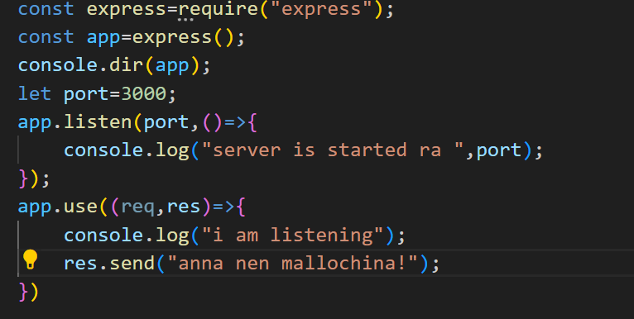

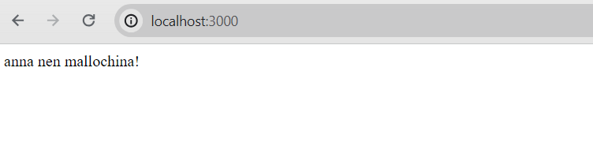

* Send method automatically converts it into json format.

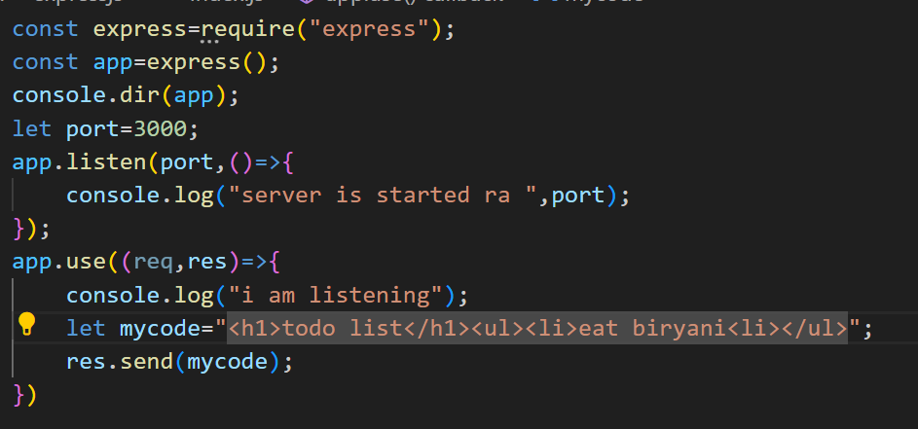

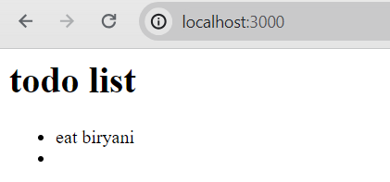

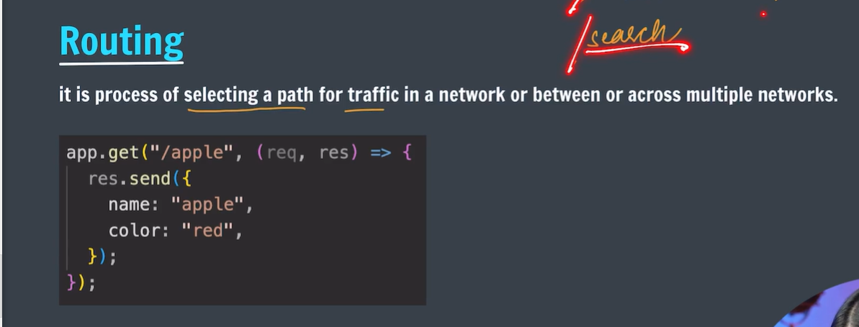

* App.use will listen all type of request even if there are different routes are there.
* It will respond to only get type of requests.

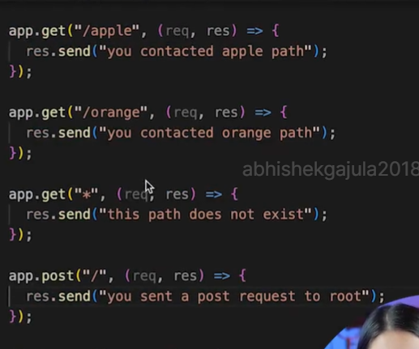

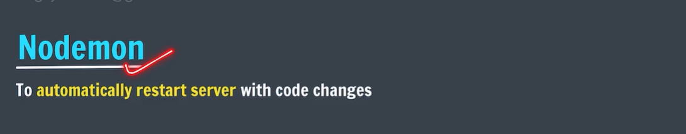

* It is good to save it in global scope.

PS F:\WEBDEVELOPMENT\Backend\expressjs> npm install -g nodemon

added 29 packages in 8s

4 packages are looking for funding

run `npm fund` for details

* Now you can check by command “nodemon -v”

# Error alert:

PS F:\WEBDEVELOPMENT\Backend\expressjs> nodemon -v nodemon : File C:\Users\user\AppData\Roaming\npm\nodemon.ps1 cannot be loaded because running scripts is disabled on this system. For more information, see about_Execution_Policies at https:/go.microsoft.com/fwlink/?LinkID=135170. At line:1 char:1 + nodemon -v + ~~~~~~~ + CategoryInfo : SecurityError: (:) [], PSSecurityException + FullyQualifiedErrorId : UnauthorizedAccess

The error message you are encountering is due to the execution policy settings in PowerShell, which prevent the running of scripts. To resolve this, you need to change the execution policy. Here are the steps to do that:

1. **Open PowerShell as Administrator:**
   * Search for "PowerShell" in the Start menu.
   * Right-click on "Windows PowerShell" and select "Run as administrator".
2. **Change the Execution Policy:**
   * In the PowerShell window, enter the following command to set the execution policy to allow scripts to run:

powershell

Copy code

Set-ExecutionPolicy RemoteSigned -Scope CurrentUser

* + Press **Enter**.

1. **Confirm the Change:**
   * You might be prompted to confirm the change. Type **Y** and press **Enter**.
2. **Verify the Change:**
   * You can verify that the policy has been changed by running:

powershell

Copy code

Get-

* 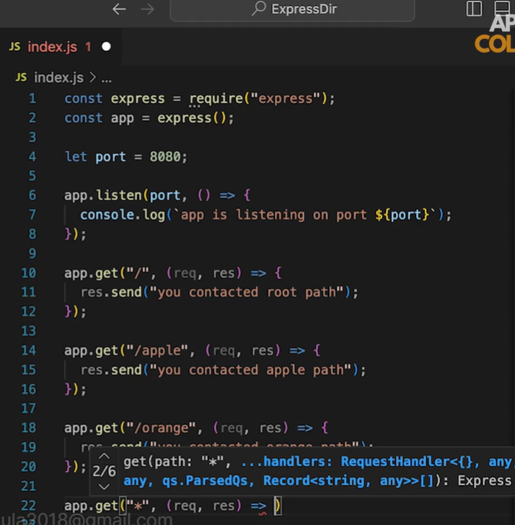
* The responding of get method is restricted to certain requests only .
* The last get method Indicates it responsible for all the request other than specified above.
* Unable to declare get method for every type route.to overcome this we use path parameters.

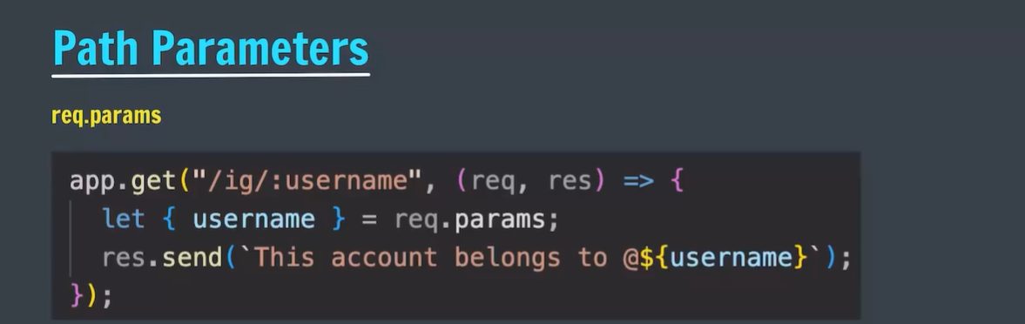

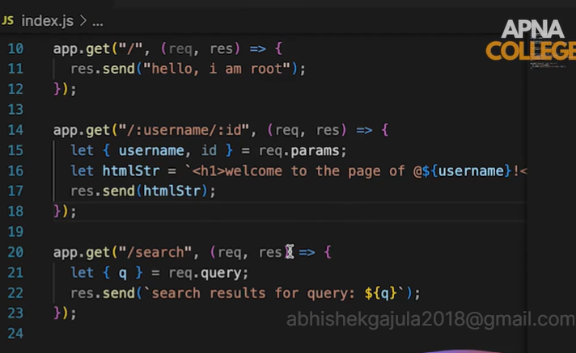

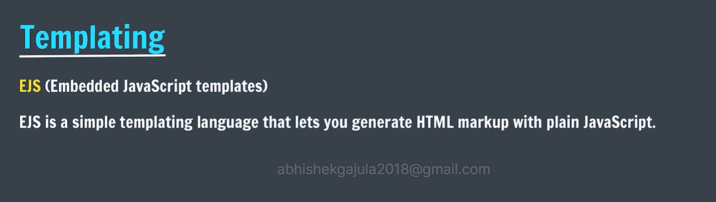

* Create a separate folder and type npm init.(use npm init -y=> it creates project with same basic profile).
* And install ejs by typing “npm install ejs”
* We no need to require ejs it comes with by default In acquiring of express

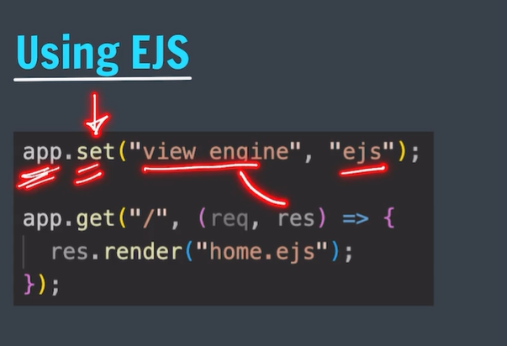

* In the context view indicate template.

Using **app.set("view engine", "ejs");** in an Express.js application is essential for setting up EJS (Embedded JavaScript) as the template engine. Here's why this line of code is important:

* **Template Engine Configuration**: Express needs to know which template engine to use for rendering views. By setting **"view engine"** to **"ejs"**, you are informing Express that EJS should be used for rendering **.ejs** files.
* **Simplifies Render Calls**: With this configuration, when you use **res.render()**, you can omit the file extension. For example, **res.render("index")** will automatically look for **index.ejs** in the views directory, making your code cleaner and easier to read.

Rendering, in the context of web development, refers to the process of generating and displaying HTML content to the client (usually a web browser) based on some source data and a template. This can happen on the server side, client side, or a combination of both.

### Types of Rendering:

* **Server-Side Rendering (SSR)**:
  + **Definition**: The process where the server generates the HTML content of a web page before sending it to the client's browser.
  + **How It Works**: The server takes data, combines it with a template, and produces a complete HTML page which is then sent to the client.
  + **Example**: Using Express with EJS in Node.js to render a webpage.

javascript

Copy code

app.get('/', (req, res) => { res.render('index', { title: 'My EJS Page', message: 'Hello, EJS!' }); });

* + **Benefits**: Faster initial page load, better for SEO, works without JavaScript enabled on the client side.
* **Client-Side Rendering (CSR)**:
  + **Definition**: The process where the browser (client) generates the HTML content using JavaScript.
  + **How It Works**: The server sends a basic HTML file with JavaScript code. The JavaScript code runs in the browser, fetching data and updating the HTML content dynamically.
  + **Example**: Using frameworks/libraries like React or Angular.

javascript

Copy code

ReactDOM.render(<App />, document.getElementById('root'));

* + **Benefits**: More dynamic and interactive applications, faster subsequent page loads after the initial load.
* Note: we have to create an “views” folder which contains ejs templates.
* Usually we use send function to send all type of data but it is not suitable for large objects where res.render() will use files(generally ejs files) as there arguments.
* To create ejs files we should create views folder.
* By default express will use this folder for ejs files.

NOTE: suppose you if you run the same index file in other parent of different directory. The express will check for the views folder in current working directory itself.

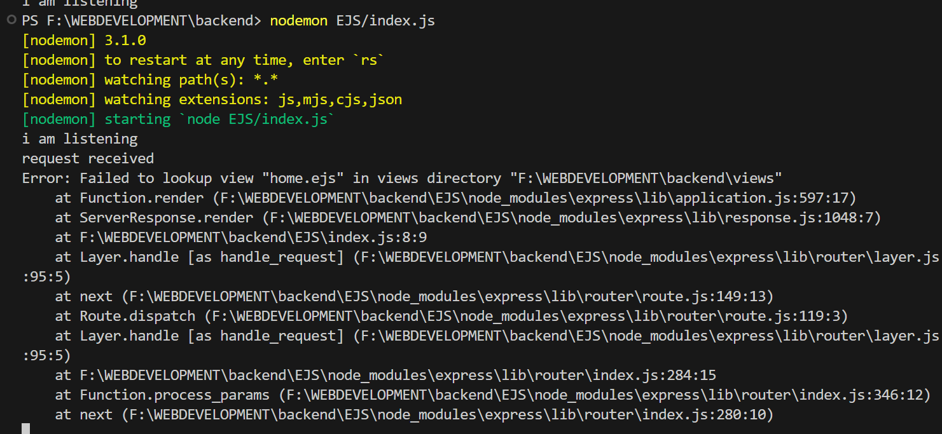

* To over come that we use the below method.

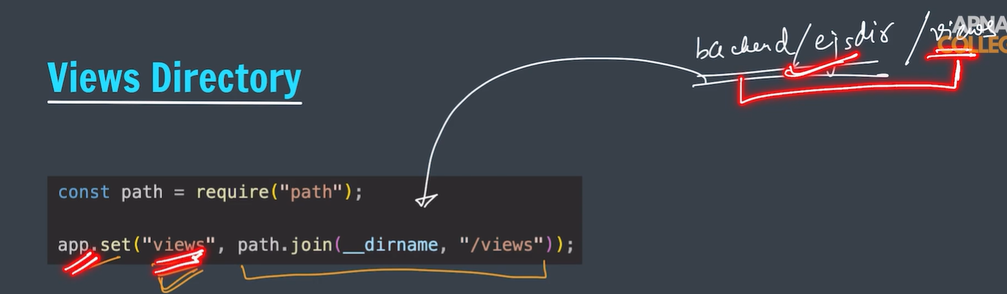

* in the first statement we importing path package.
* In the second statement we are setting the views path to the place where the original express.js file is there.
* __dirname indicates the relative address of the views where the original server file is present.

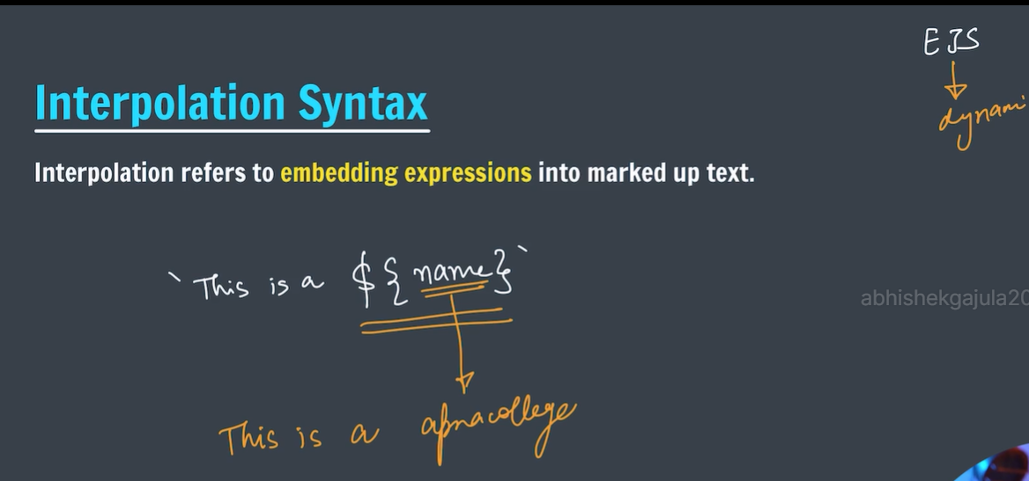

* Below one is the example program to pass the value to ejs.

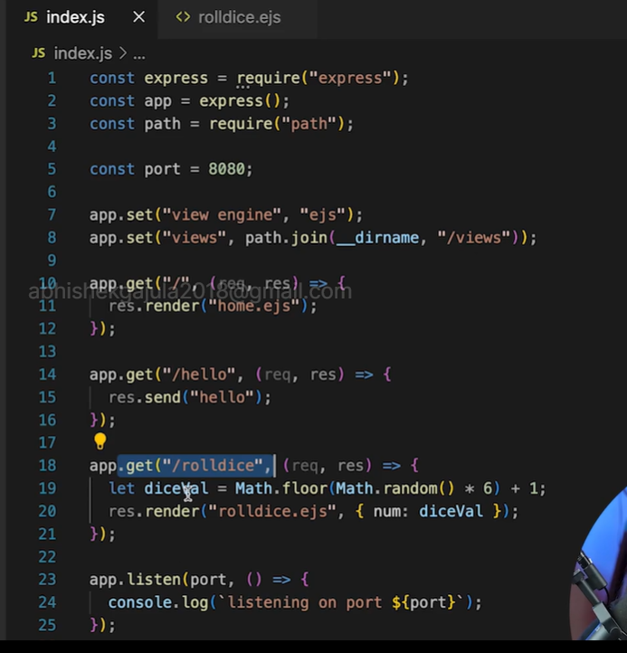

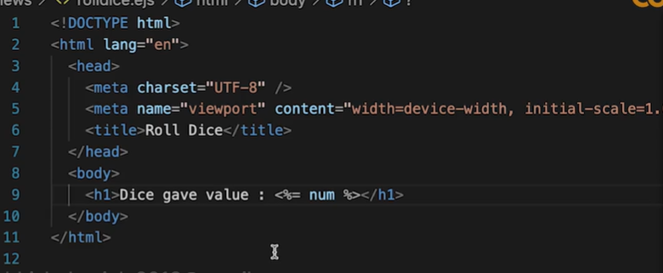

### Tags

* <% 'Scriptlet' tag, for control-flow, no output
* <%_ ‘Whitespace Slurping’ Scriptlet tag, strips all whitespace before it
* <%= Outputs the value into the template (HTML escaped)
* <%- Outputs the unescaped value into the template
* <%# Comment tag, no execution, no output
* <%% Outputs a literal '<%'
* %> Plain ending tag
* -%> Trim-mode ('newline slurp') tag, trims following newline
* _%> ‘Whitespace Slurping’ ending tag, removes all whitespace after it

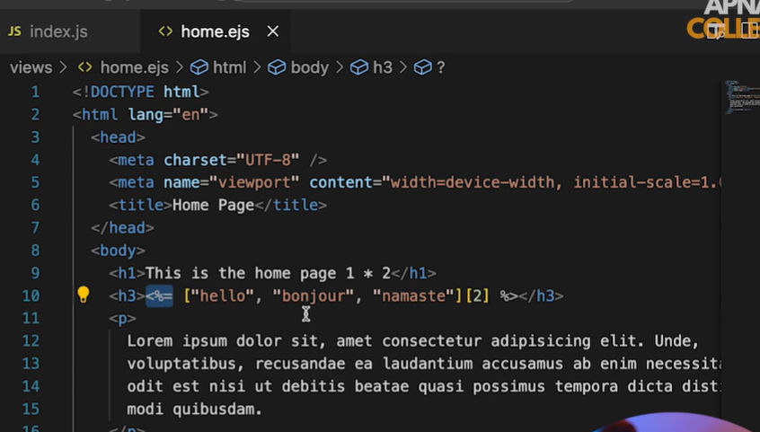

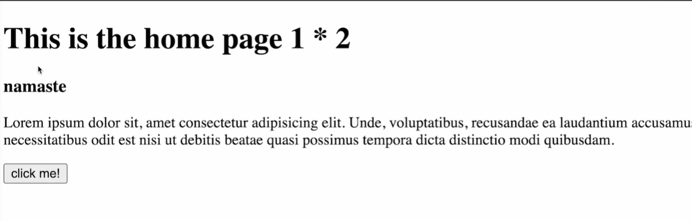

* The js code which is written in between <%= %> is evaluated and the final output is converted into string and displayed in html file.

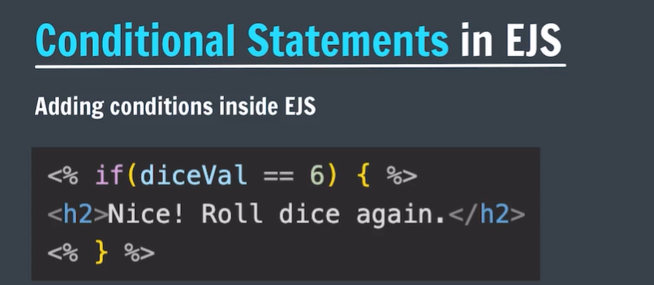

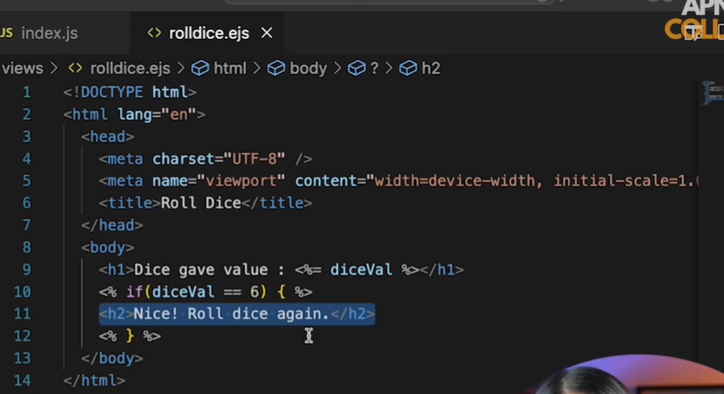

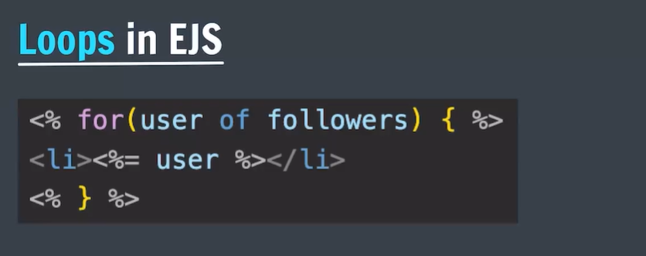

# Instagram with ejs:

* Generally we pass the data which is came form the database to the ejs file.
* So we should import that data file which is downloaded by the given link.

Problem: IN BEFORE TOPICS WE ONLY DISCUSSED ABOUT DYNAMIC HTML ONLY.

BUT THERE IS OTHER FILES ALSO SHOULD BE ATTACHED (CSS , JS FILES).

* **TO SOLVE ABOVE PROBLEM WE CAN USE BELOW TECHNIQUE.**

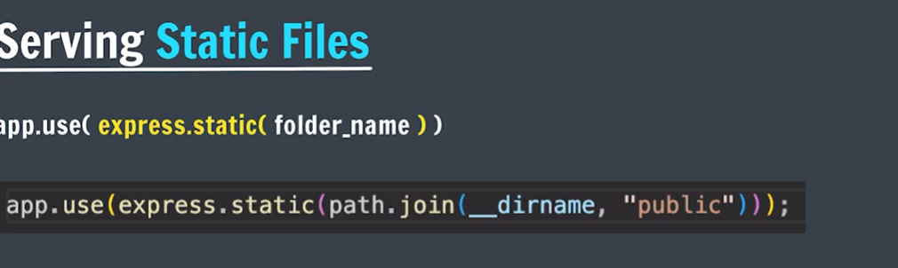

* Express.static(folder-name) is called as middleware.
* The folder_name specifies place where static files are present.
* With same filename we have to create a dir with in the same dir.
* In that we have to keep the files like css and js.

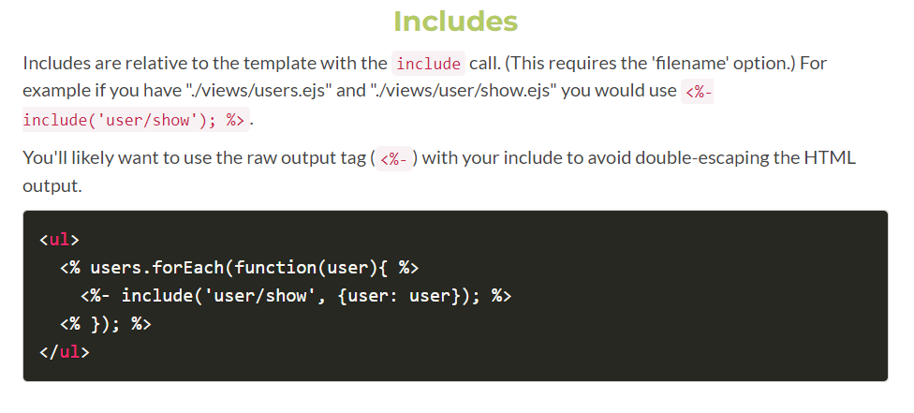

* Includes us used for substituting the sub templates.
* For example:metadata is almost is equal to all the ejs file so that we substitute that head using includes.
* Includes uses ejs tag the includes html file .

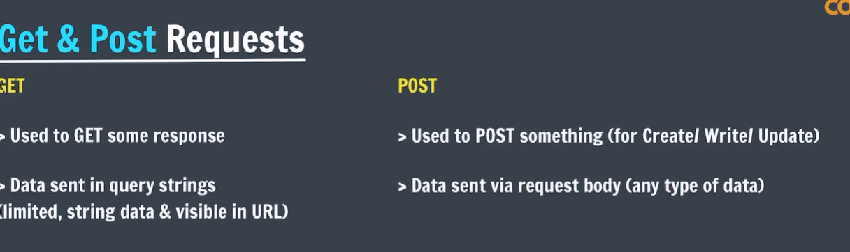

* We can access the data which is coming from query strings.
* But to access the data which is coming from post we should follow the below process.

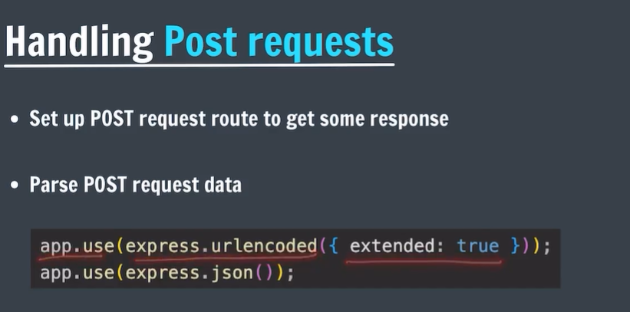

* Express cannot directly access the data which coming with post request.
* To get understand the data we should use above two lines of code to parse the post request.

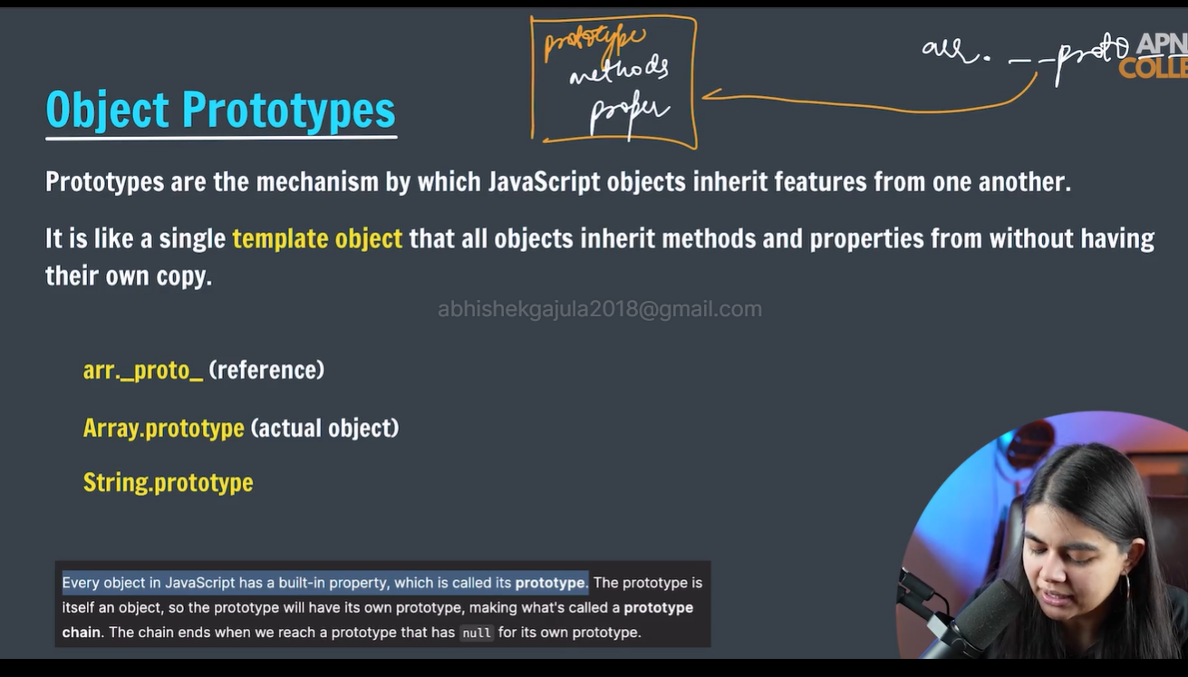

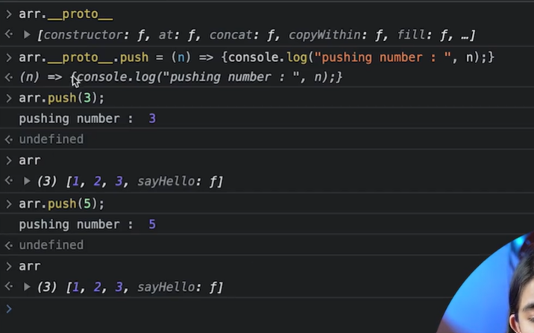

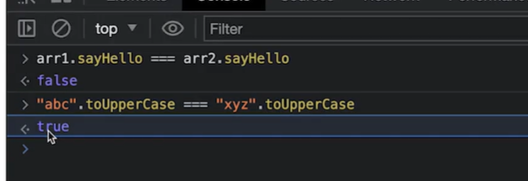



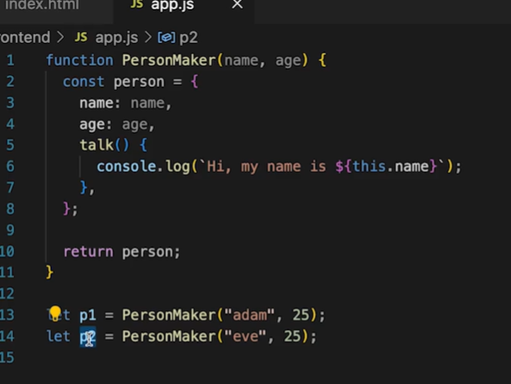

* The disadvantage is every object has its own copy of talk() function.
* To overcome the above disadvantage we can use new operator.

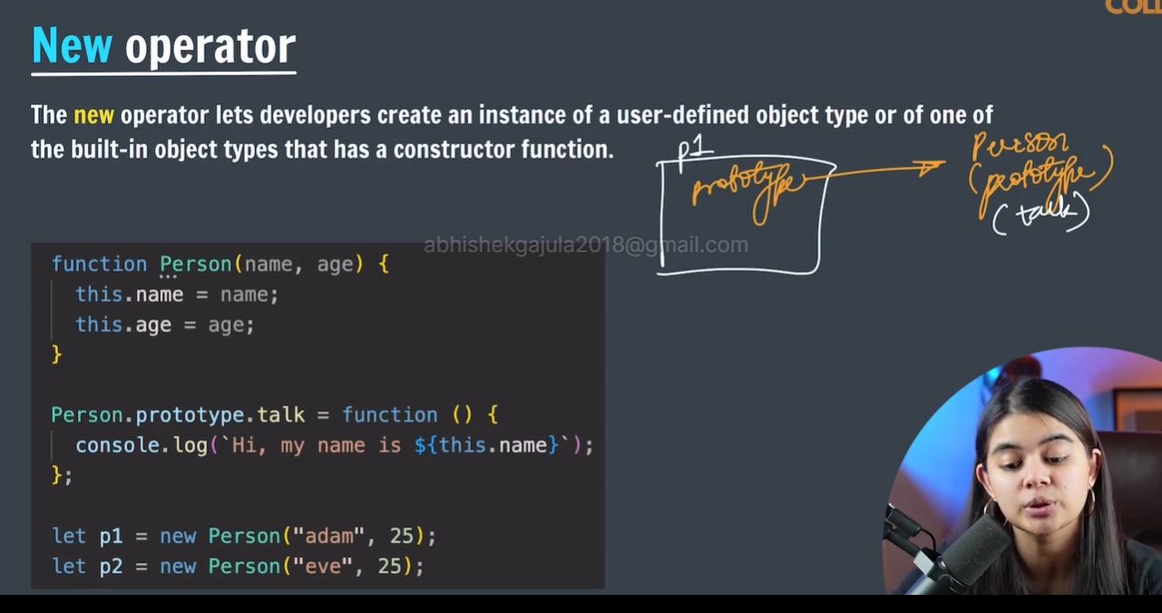

## [Description](https://developer.mozilla.org/en-US/docs/Web/JavaScript/Reference/Operators/new#description)

When a function is called with the **new** keyword, the function will be used as a constructor. new will do the following things:

1. Creates a blank, plain JavaScript object. For convenience, let's call it newInstance.
2. Points newInstance's [[Prototype]] to the constructor function's prototype property, if the prototype is an [Object](https://developer.mozilla.org/en-US/docs/Web/JavaScript/Reference/Global_Objects/Object). Otherwise, newInstance stays as a plain object with Object.prototype as its [[Prototype]].

**Note:** Properties/objects added to the constructor function's prototype property are therefore accessible to all instances created from the constructor function.

1. Executes the constructor function with the given arguments, binding newInstance as the [this](https://developer.mozilla.org/en-US/docs/Web/JavaScript/Reference/Operators/this) context (i.e. all references to this in the constructor function now refer to newInstance).
2. If the constructor function returns a [non-primitive](https://developer.mozilla.org/en-US/docs/Web/JavaScript/Data_structures#primitive_values), this return value becomes the result of the whole new expression. Otherwise, if the constructor function doesn't return anything or returns a primitive, newInstance is returned instead. (Normally constructors don't return a value, but they can choose to do so to override the normal object creation process.)

Note : if we use this key word in constructor without new keyword it will return window object but with constructor it will return its own object.

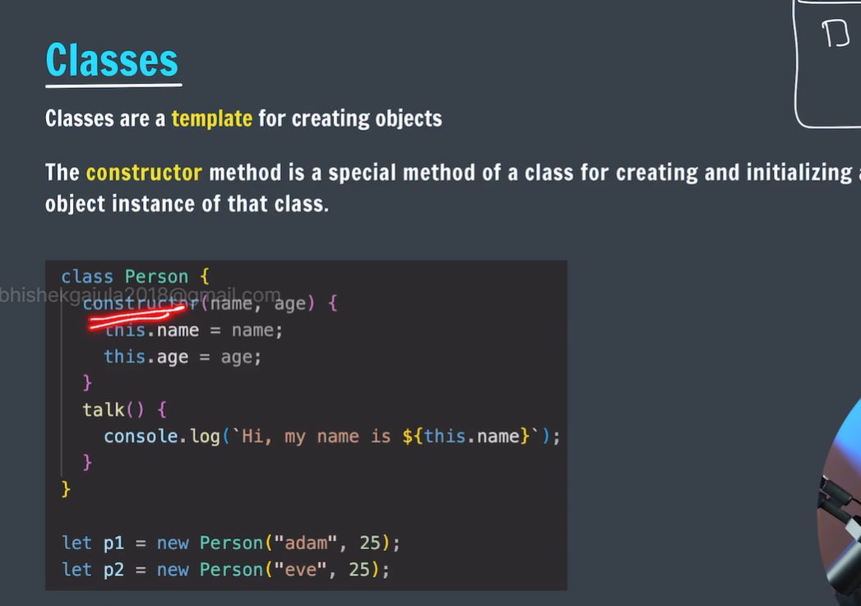

* Classes by default create prototype for the function.

